 | Admin | Worker | Ships
View Contract | View All Ships contracts | View only selected ships contracts | they only see need sign contracts
Delete contracts
Deactivate contacts
Activate contracts
Redacte contacts |  | When worker need redacte,Admin give acces to redacte with notification
Notification | 1.when worker add contract 2.when worker deactivate contract(with note) 3.when sign contract  4.when worker activate contract.  5.when contact signed  6.when contact ended  7.When contact end -1 month | 1.when contact signed  2.when contact ended  3.When contact end -1 month

Dashboard worker
1.Contract wait sign
2.Active Contract count for each ships
3.Graphic contact added for 1 month

Dashboard Admin
1. Active Contract count for all worker
2. Active Contract count for all ships
3.Graphic contact added for 1 month

2.Add date picker when select date in everywhere

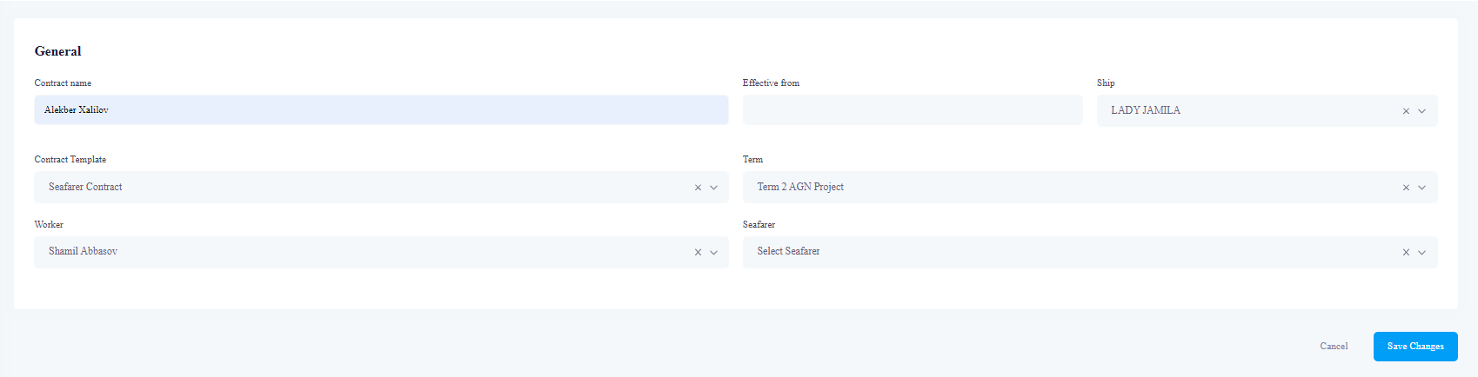

3.Change Status - DONE
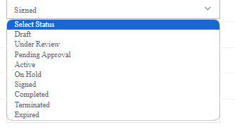

leave only
1.Draft - grey
2.Pending Sign - flashing yellow
If signed
3.Signed - Blue
4.Active - Green
5.Deactivated – red

4.Add Action Button - Deactivate – when click button worker add note and deactivate contract
5.In Email Template add select Ship.

Contract View
1.When send to sign
next
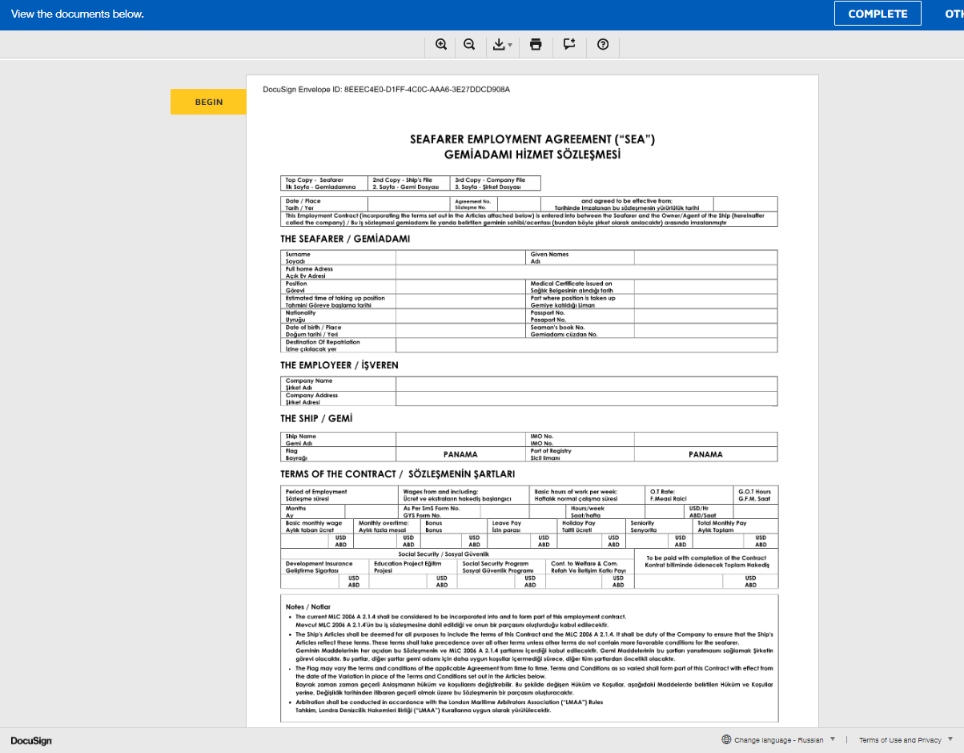
In right we show begin the document
Change sign document to Complete and Next button.
Add Zoom,Download pdf and print button.

Show each page as separate
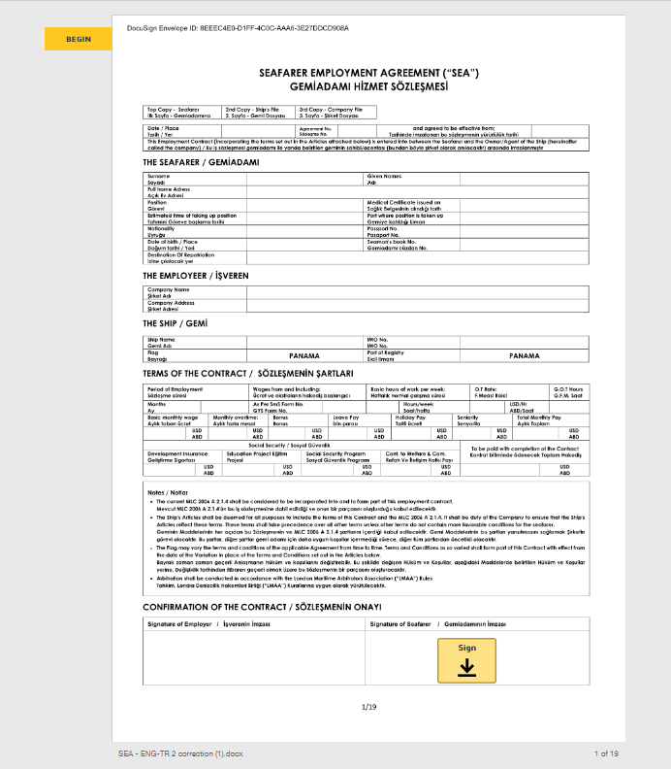
Qr code

Add qr code

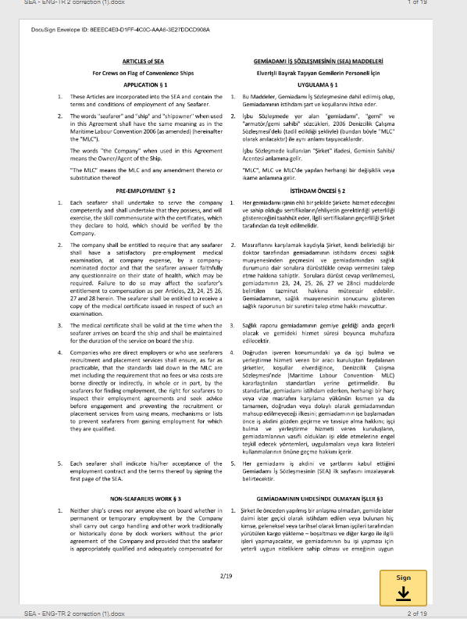

Add Sign Button
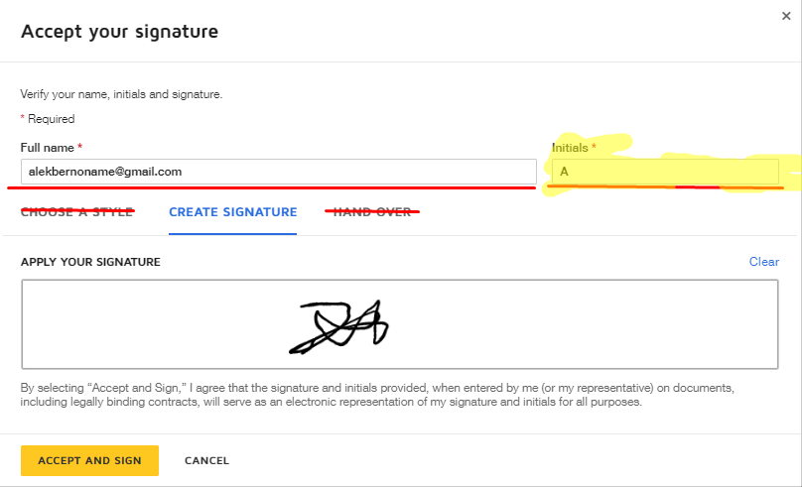
When click sign in first page signature add in every page
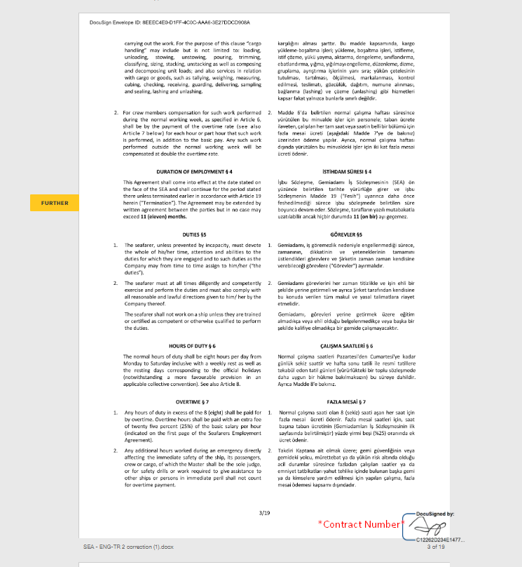
Contarct Number – Sign

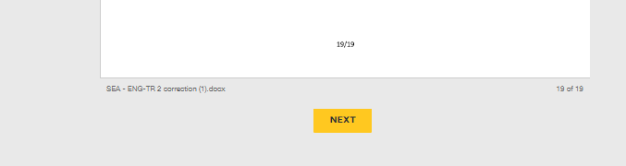

In end document add next button

Only in Seafarer sign panel User can change language.
English and Turkish

When End Sign Seafarer can download and Print Contract.

After sign in upper document add block
ACTIVE

When contact end and deactivate
deactive

…

